请在论文第一页附上查重报告截图（turnitin），重复率请控制在20%以下，不得高于30%
全文查重（含文献）
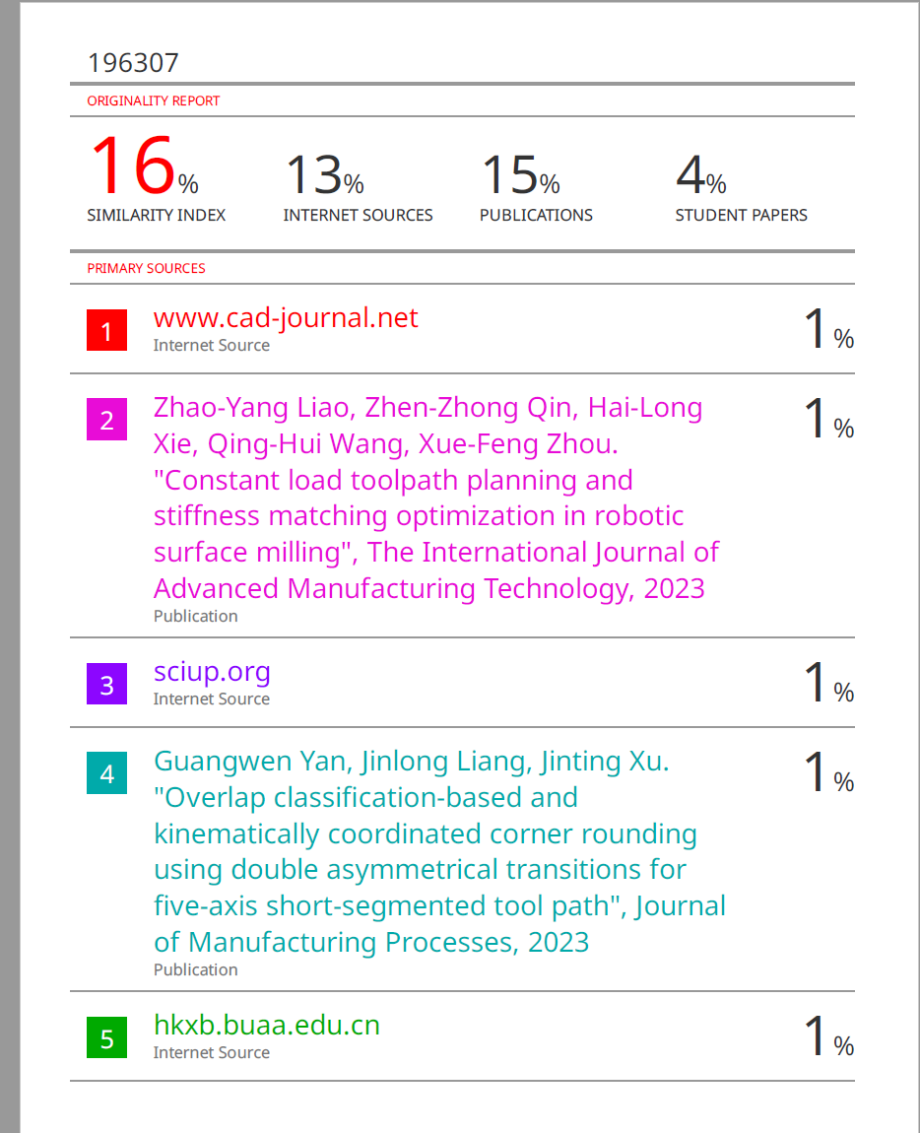
论文中使用的图片必须要有授权许可
论文要6页以上
页面尺寸设置如下：
页边距：上：5.2厘米，下：5.2厘米，左：4.4厘米，右：4.4厘米
纸张大小：A4（宽度：21厘米，高度：29.7厘米）
布局：页眉：4.2厘米 ，页脚4.1厘米
无网格
Contribution Title（题目字体：Times New Roman字号四号，加粗，居中，段后24 磅，最小值18 磅）
First Author¹[0000-1111-2222-3333] and Second Author²[1111-2222-3333-4444] （作者名字字体：Times New Roman，字号10，居中，段后10 磅，最小值11 磅）作者名字要全称，先名后姓
¹ Princeton University, Princeton NJ 08544, USA
² Springer Heidelberg, Tiergartenstr. 17, 69121 Heidelberg, Germany
lncs@springer.com
（作者单位和作者邮箱字体Times New Roman，字号小五，居中）
Abstract. The abstract should summarize the contents of the paper in short terms, i.e. 150-250 words. （摘要的字体Times New Roman，字号小五，左侧1 厘米，右侧1 厘米，段前30 磅，最小值11 磅）
Keywords: First Keyword, Second Keyword, Third Keyword. （关键词字体Times New Roman，字号小五，左侧1 厘米，右侧1 厘米，段前11 磅，段后18 磅，最小值11 磅）
- First Section（一级标题字体Times New Roman，字号小四，加粗，段前18 磅，段后12段，悬挂1 厘米，最小值15磅）
  - A Subsection Sample（二级标题字体Times New Roman，字号10，加粗，段后8 磅，悬挂1 厘米，最小值12磅）
Please note that the first paragraph of a section or subsection is not indented. The first paragraphs that follows a table, figure, equation etc. does not have an indent, either.
Subsequent paragraphs, however, are indented. （正文内容字体Times New Roman，字号10，最小值12磅）
标题下的第二段起首行缩进0.4 厘米

Sample Heading (Third Level). Only two levels of headings should be numbered. Lower level headings remain unnumbered; they are formatted as run-in headings. （三级标题不编号，字体Times New Roman，字号10，加粗，段前18磅，最小值12磅）

Sample Heading (Forth Level). The contribution should contain no more than four levels of headings. The following Table 1 gives a summary of all heading levels. （四级标题不编号，字体Times New Roman，字号10，倾斜，段前12磅，最小值12磅）
Table 1. Table captions should be placed above the tables.
（表格标题字体Times New Roman，字号小五，居中，段前12 磅，段后6 磅，最小值11磅）
Heading level | Example | Font size and style
Title (centered) | Lecture Notes | 14 point, bold
1st-level heading | 1 Introduction | 12 point, bold
2nd-level heading | 2.1 Printing Area | 10 point, bold
3rd-level heading | Run-in Heading in Bold. Text follows | 10 point, bold
4th-level heading | Lowest Level Heading. Text follows | 10 point, italic
（表格里面的字体Times New Roman，字号小五）
Displayed equations are centered and set on a separate line.
x + y = z (1)
Please try to avoid rasterized images for line-art diagrams and schemas. Whenever possible, use vector graphics instead (see Fig. 1).
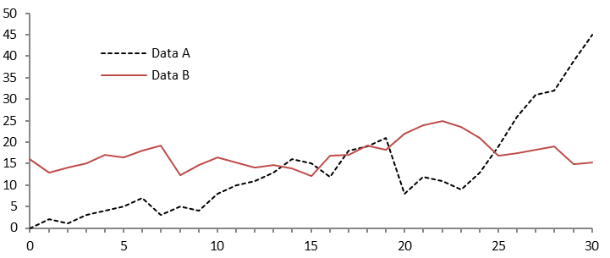
Fig. 1. A figure caption is always placed below the illustration. Short captions are centered, while long ones are justified. The macro button chooses the correct format automatically.
（图片标题字体Times New Roman，字号小五，居中，段前6 磅，段后12磅，最小值11 磅）
For citations of references, we prefer the use of square brackets and consecutive numbers. Citations using labels or the author/year convention are also acceptable. The following bibliography provides a sample reference list with entries for journal articles [1], an LNCS chapter [2], a book [3], proceedings without editors [4], as well as a URL [5].

References
- Author, F.: Article title. Journal 2(5), 99–110 (2016).
- Author, F., Author, S.: Title of a proceedings paper. In: Editor, F., Editor, S. (eds.) CONFERENCE 2016, LNCS, vol. 9999, pp. 1–13. Springer, Heidelberg (2016).
- Author, F., Author, S., Author, T.: Book title. 2nd edn. Publisher, Location (1999).
- Author, F.: Contribution title. In: 9th International Proceedings on Proceedings, pp. 1–2. Publisher, Location (2010).
- LNCS Homepage, http://www.springer.com/lncs, last accessed 2016/11/21.
（参考文献正文字体Times New Roman，字号小五，左侧0.4 厘米，悬挂缩进0.2 厘米，最小值11 磅）
References不能少于10条、且须列明其DOI或者查询网址

注意事项
所有图片，表格，参考文献 必须要在正文明确且正确的引用
公式和表格必须要可编辑状态，不可以用图片形式来呈现
所有图片必须要高清，能够清楚看到图片里面的内容
全文查重（含文献），查重率需控制在20%以下，不得高于30%

